**CGPA Calculator Project (Java GUI)**

# Project Overview

This project is a Java Swing-based GUI application to calculate SGPA and CGPA. Users input grades and credits to get SGPA or input SGPA and credits for each semester to compute CGPA. This demonstrates modular code and the use of weighted average concepts in academic grading.

# Formulas Used

1. SGPA (Semester Grade Point Average):

SGPA = (Sum of (Credit × GradePoint)) / (Total Credits)

1. CGPA (Cumulative Grade Point Average):

CGPA = (Sum of (SGPA × SemesterCredits)) / (Total SemesterCredits)

# How to Run the Project

1. Open IntelliJ IDEA.
2. Create a new Java project.
3. Add a new Java Class file named 'Main.java'.
4. Paste the provided code into Main.java.
5. Run the file using the green Run button or right-click > Run 'Main.main()'.

# Output

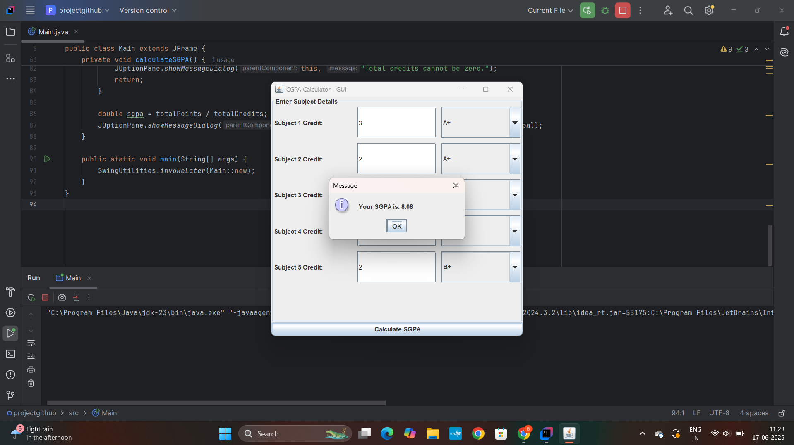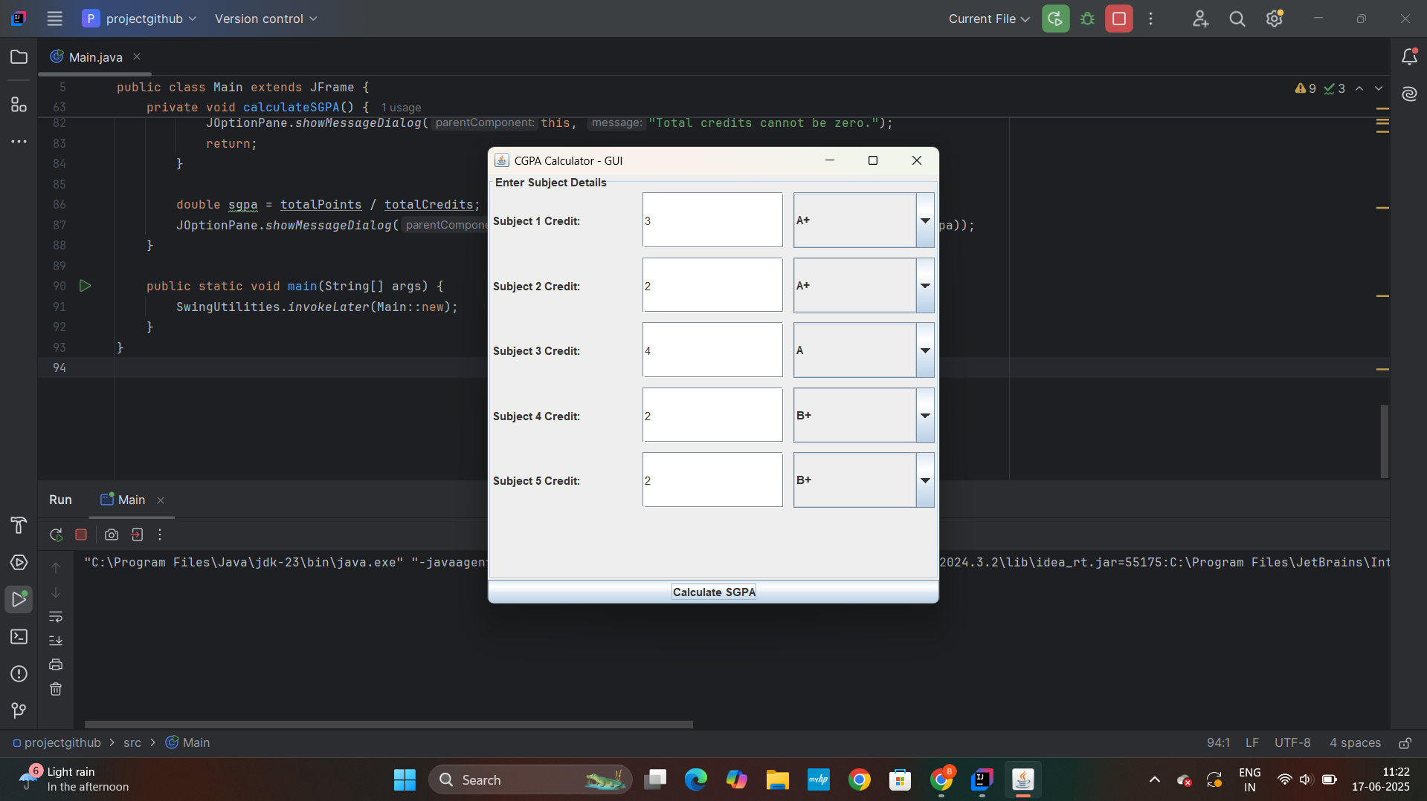

# SGPA vs CGPA - Similarities and Development

Both SGPA and CGPA use weighted averages. SGPA is calculated per semester using subject-wise grade points and credits. CGPA is calculated across semesters using SGPA values and their corresponding semester credits. The CGPA calculator is conceptually an extension of the SGPA calculator over multiple semesters.

# Differences in Code

* SGPA Calculator:

Input: Grade points & credits for each subject

Logic: Multiply each grade point with its credit, sum the result, divide by total credits.

* CGPA Calculator:

Input: SGPA and credits for each semester

Logic: Multiply SGPA of each semester by its credit, sum the results, divide by total semester credits.

Thus, only the level of abstraction differs - subject vs semester.

**SGPA vs CGPA Calculator Project (Java GUI)**

# Conclusion

This Java GUI project is a beginner-friendly implementation that bridges academic concepts with GUI programming. The SGPA logic naturally extends into CGPA, showcasing code reuse and fundamental averaging principles.